学习目标：掌握重点短语并应用：Talk quietly. Keep your desk clean
Keep to the right. Talk turns.
一、请选出与例词划线部分读音相同的选项。（10分）
1. try ( ) A. you B. light C. say
2. night ( ) A. why B. big C. Amy
3. quiet ( ) A. quite B.white C. uncle
4. do ( ) A. woods B. go C. collect
5. catch ( ) A. play B. have C. watch
二、 请选择正确的答句，把序号填在括号里。（ 10分）
( ) 1.Is the cat sleeping? A. Yes, they are.
( ) 2.W hat is your mother doing? B. I'm collecting leaves.
( ) 3.Are the monkeys jumping? C.She is cooking dinner.
( ) 4.Is Bai Ling writing a report? D. No, it isn’t.
( ) 5. What are you doing? E.Yes, she is.
三、请根据图画内容填充句子。(15分)

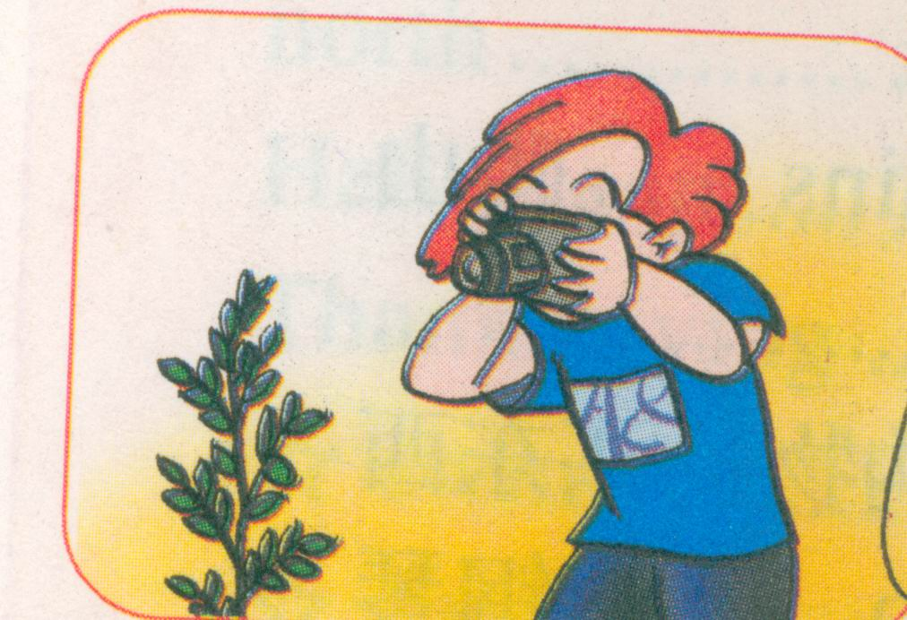
1. -----------What is Mike doing ? -----------He’s__________________.

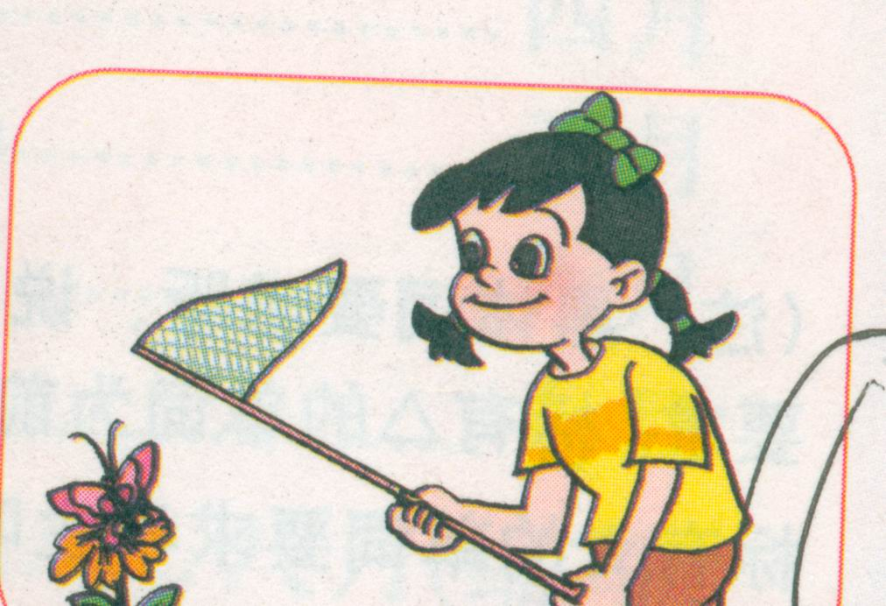
2. -----------Is Chen Jie counting insects?
-----------No, she is_________________.

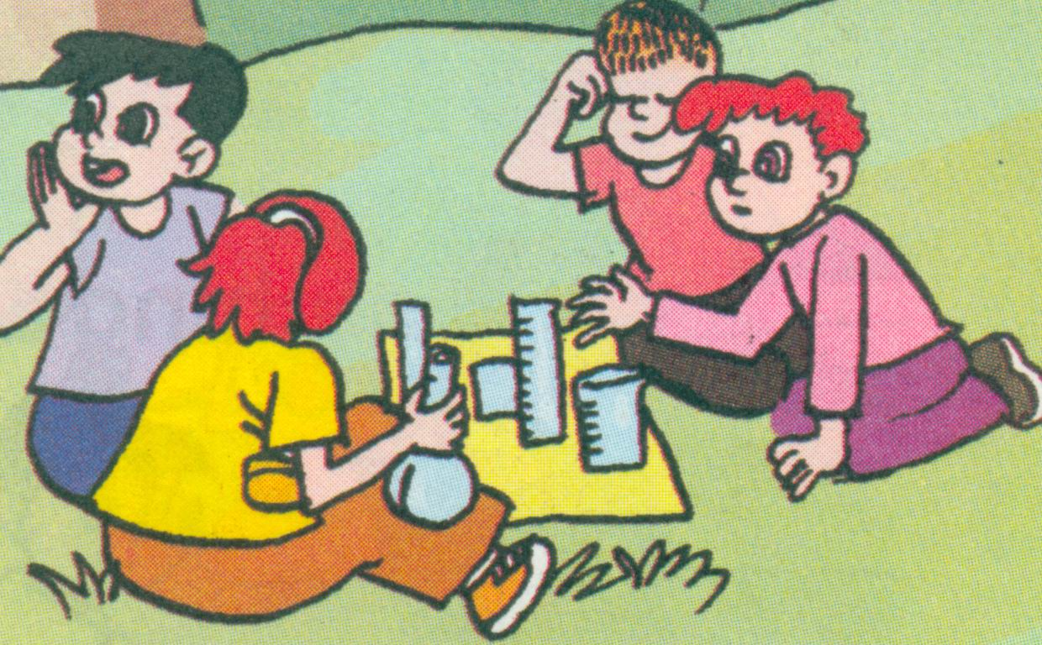
3. ----------- Are they ________________?
-----------Yes, they are.
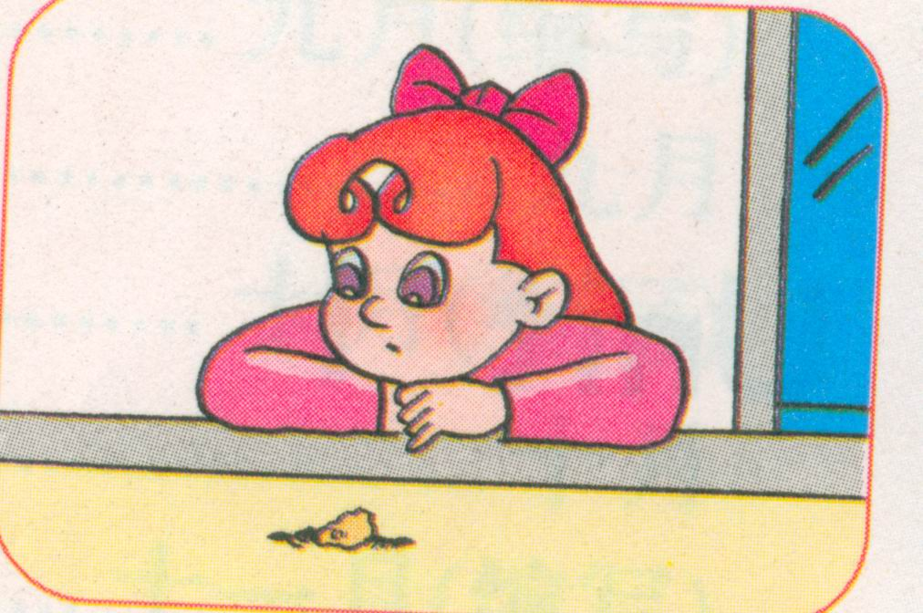
4. ----------- What is Chen Jie doing?
-----------She’s ___________________.

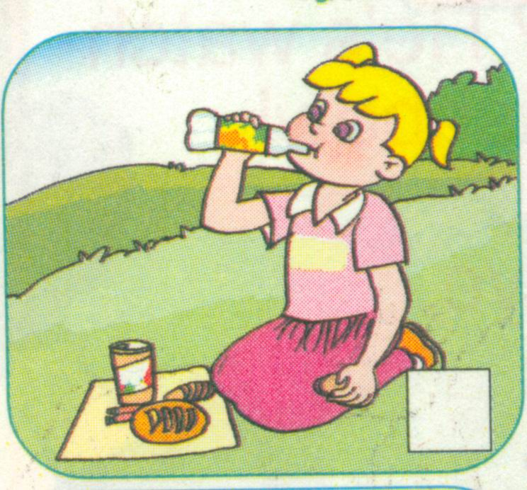
5. -----------Is Lily having a picnic ?
-----------Yes, __________.

四、 请选出下列单词中不同类的一项。（10分）
1. ( )A. pictures B. books C. fly
2.( ) A. she B. book C. he
3. ( )A. walk B. jumping C. fighting
4. ( )A. watching insects B. counting leaves C.pick up leaves
5. ( )A. kangaroo B. leaves C. monkey
五、请选出相应的答案，把句子补充完整。（10分）
1. -----------What is John doing?
-----------______________________
A. He is eating lunch.
B. She is pick up leaves.
C. Watch TV.
2. Amy is under the tree. _______ collecting leaves.
A. She is B. she’s C. he is
3. -----------Are your classmates having a picnic?
-----------______________________
A. Yes, he is. B. No, they are. C. No, they aren’t.
4. -----------Is Sarah ______________?
-----------Yes, she is .
A. write a report B. watching insect C. picking up leaves
5. ----------- ____________________ ?
-----------They are catching butterflies.
A. Are they catching butterflies ?
B. What are they doing ?
C. Where are they?

